

Studio3T Task

**Student Name:   Pham Hong Phuc**

**Student ID:  001284212**

In this week task, the main assignment focused on MongoDB aspect of the MEVN stacks, but since the resources in the database program is not as informative and professional as Studio3T, it will be replaced as Studio3T to take over the demonstration.

Here is a quick look of the document-oriented database program that is classified as a NoSQL product. Minimal usage of schemas since they are optional.

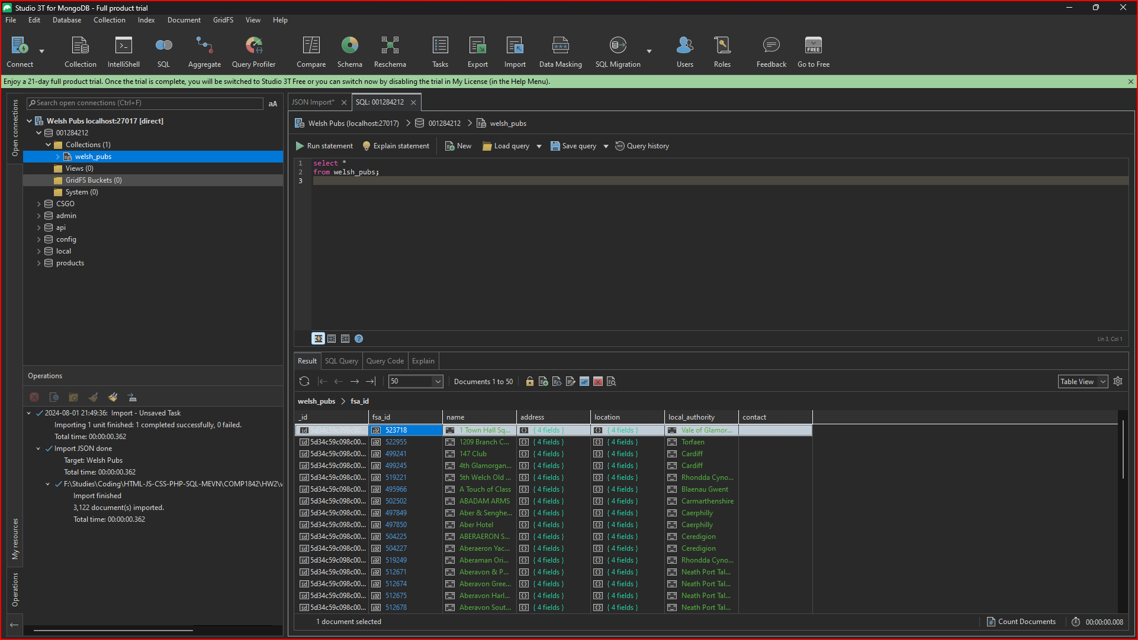

We will be importing a provided .json file to read; then, we will have columns of properties from the .json document.

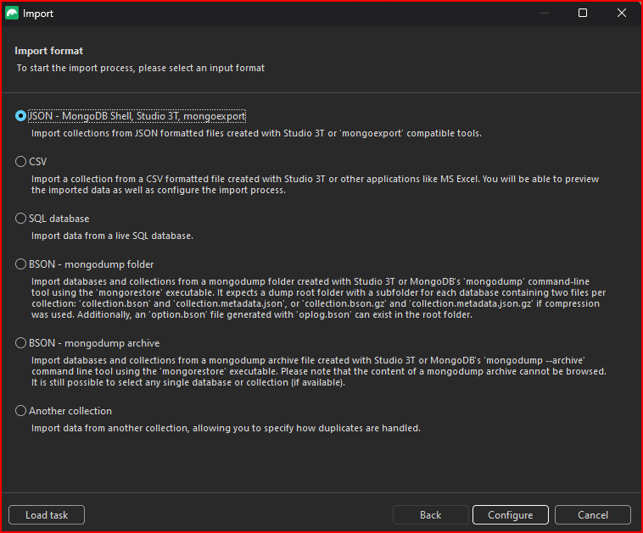

The others are fine to utilize the data, but .json files are always have a standardized written style to read data easily and freely.

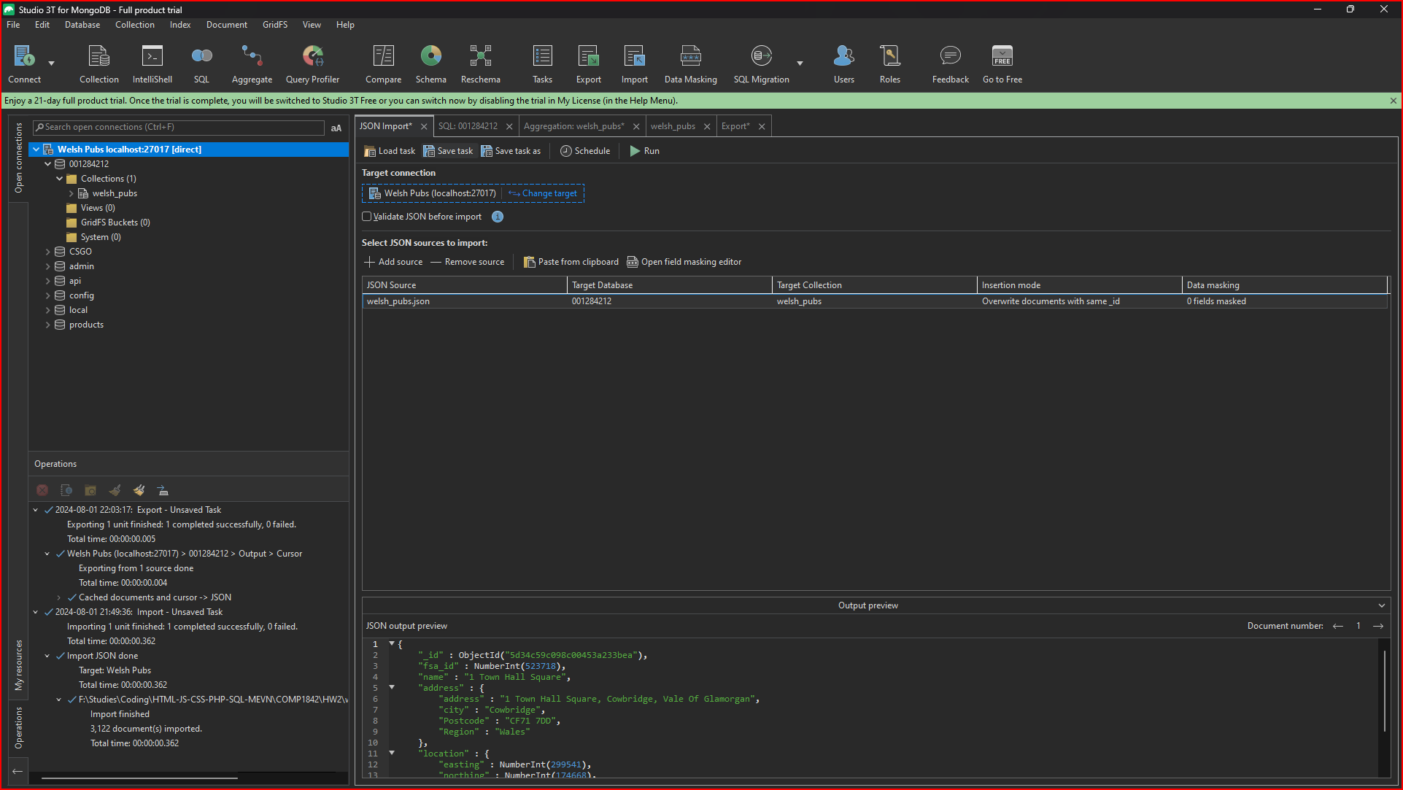

From scratch, a feature in the software that called ‘pipeline’ to operate as an unlimited number of tabs to perform different schema purposes or could be called sketches.

In this contextual image of NoSQL, 2 specific keys are called out to match with similar 2 values within the .json file columns.

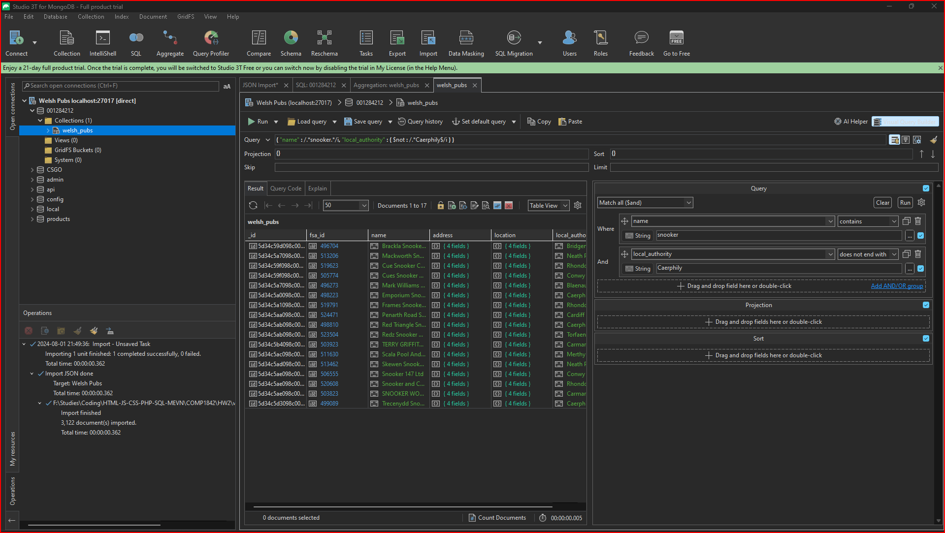

In the next case, the file imported is considered to be table that contains complex and compiled data, similar format as traditional SQL results.

The difference is that we type out data on data storing format files to make as many tables as possible and operate less complicated schemas. With a single key that equal to any value from the .json file, the output will be declared.

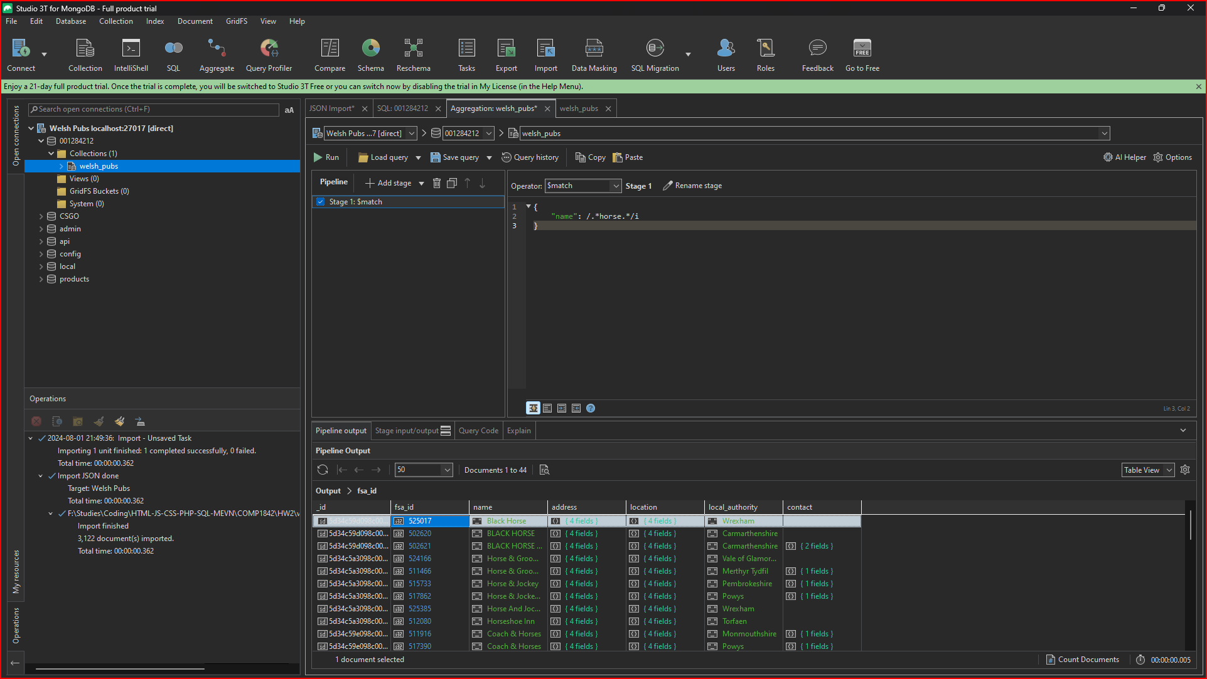

In the final part, the export operator successfully used to take out a .json file from the previous results. The exported file should be outside at the expected set path.

